GCSE - Hydrographs in the River Culm catchment worksheet

- Use the data below to construct a hydrograph for the River Culm for 30/10/2008.
Hours | Discharge (cumecs)
0 | 2
5 | 5
10 | 20
15 | 100
20 | 137
25 | 60
30 | 30
35 | 18
40 | 15
45 | 10
50 | 8
55 | 7
60 | 5
Total rainfall: 48mm
- Plot the data for the flood hydrograph onto graph paper, with hours on the X axis and river flow in cumecs on the Y axis.
- Construct a separate Y axis for rainfall and draw a rainfall bar at 0 hours to represent 48mm.
- Give your hydrograph a title and add these labels: Rising limb, peak flow, falling limb.
- Draw a line to show the lag time and calculate the lag time in hours.
- Describe why the hydrograph can be described as flashy.
--------------------------------------------------------------------------------------------------------------------------------------
2. Study the photos below showing floods on the River Culm at Stoke Canon and Hele (2012)
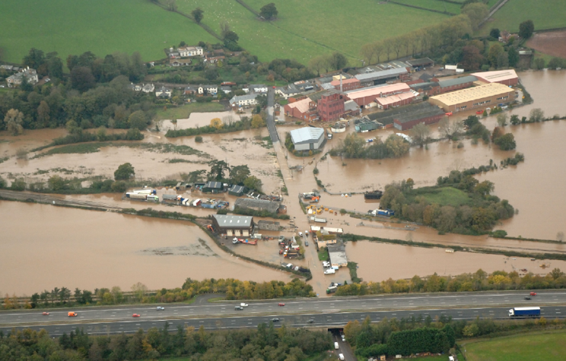
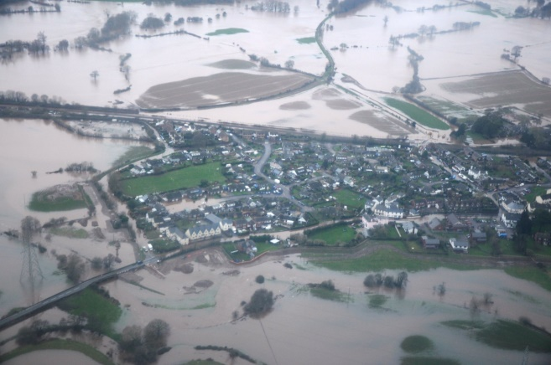
Stoke Canon Hele
Describe how a sudden rise in river levels after a storm event might affect:
- Farmers with crops or livestock on fields close to the river
- Residents with houses near the river
- The operation of the railway from London to Exeter which runs close to the river
Farmers:
----------------------------------------------------------------------------------------------------------------------------------------------------------------------------------------------------------------------------------------------------------------------------
Residents:
----------------------------------------------------------------------------------------------------------------------------------------------------------------------------------------------------------------------------------------------------------------------------
Railway:
----------------------------------------------------------------------------------------------------------------------------------------------------------------------------------------------------------------------------------------------------------------------------
- The river Culm often has a flashy response to rainfall, meaning that the hydrograph rises and falls quickly. Explain how each of the following can produce a flashy response in the River Culm catchment.
Factor | How it produces a flashy response
Geology (rock type)

Slopes

Urban areas, such as Cullompton

Farming

- Explain how the development of a new garden village near Cullompton could increase the risk of flooding on the River Culm.
----------------------------------------------------------------------------------------------------------------------------------------------------------------------------------------------------------------------------------------------------------------------------
- Suggest how climate change might affect the future shape of the River Culm hydrograph.
--------------------------------------------------------------------------------------------------------------------------------------------------------------------------------------------------------------------------------------------------------------------------------------------------------------------------------------------------------------------------------------------------------------------------------------------------------------------------------------------------------------------------------------------------------

